3D Printing Project: Keychain

- Go to Shared Folder < Template < OOO CTE < ACHS < Rhino Tutorials. Double-click on the Keychain icon.

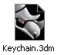

- Your screen should look like below.

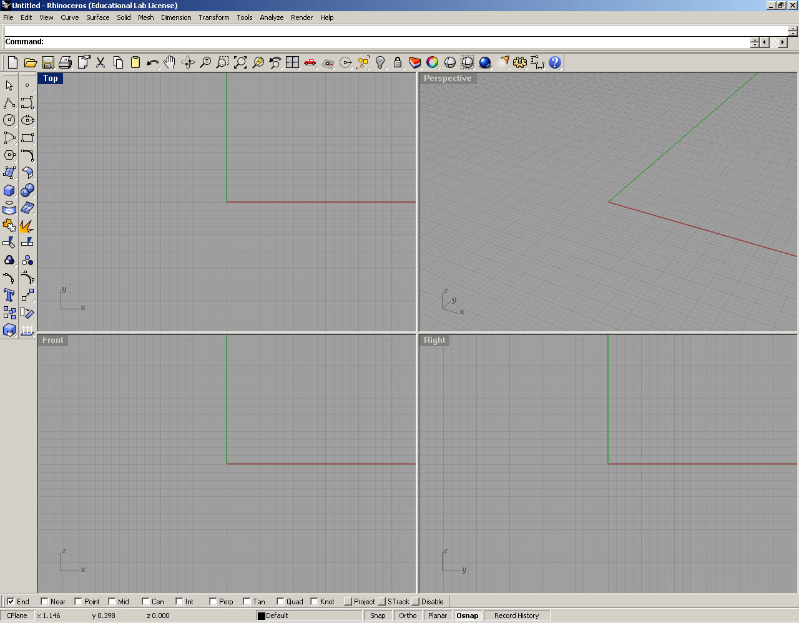3

- Double-click on the text Top. Your screen should look like below.
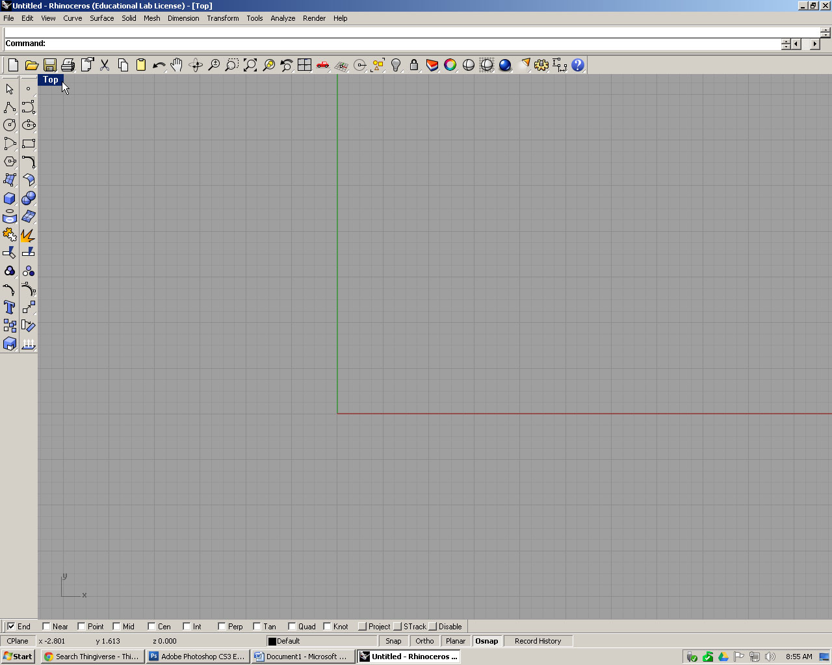

- Left-click to activate the circle tool. Then, click in the center of the screen. Enter a value of 1.5 diameter and press Enter. Your screen should look like below.
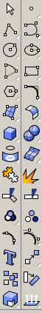
Left-click here
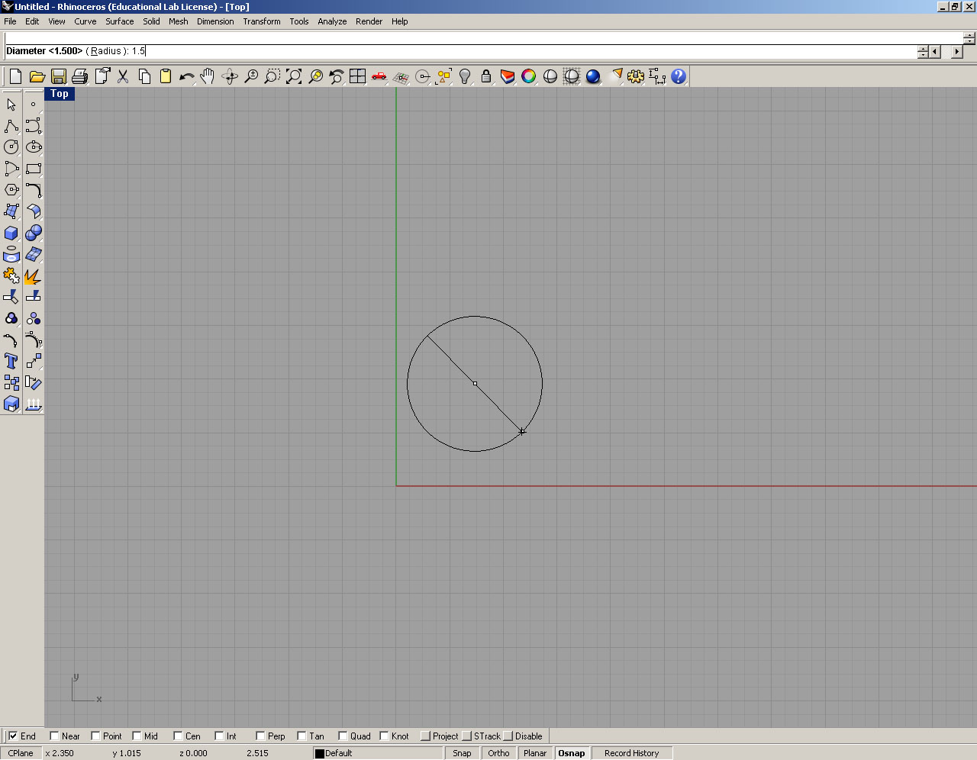
Enter 1.5 here.
- Left-click to activate the circle tool again. Then, click anywhere on the screen. Enter a value of .375 diameter and press Enter.
Left-click here.
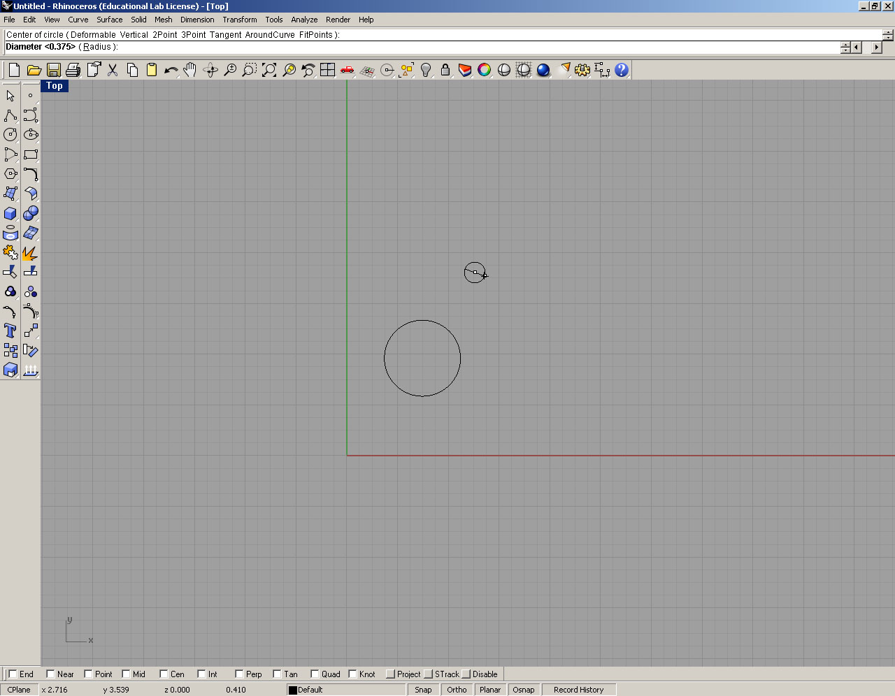
Enter .375 here.

- Click-and-hold on the smaller circle. Move the small circle so it rests just about the larger circle. See below.

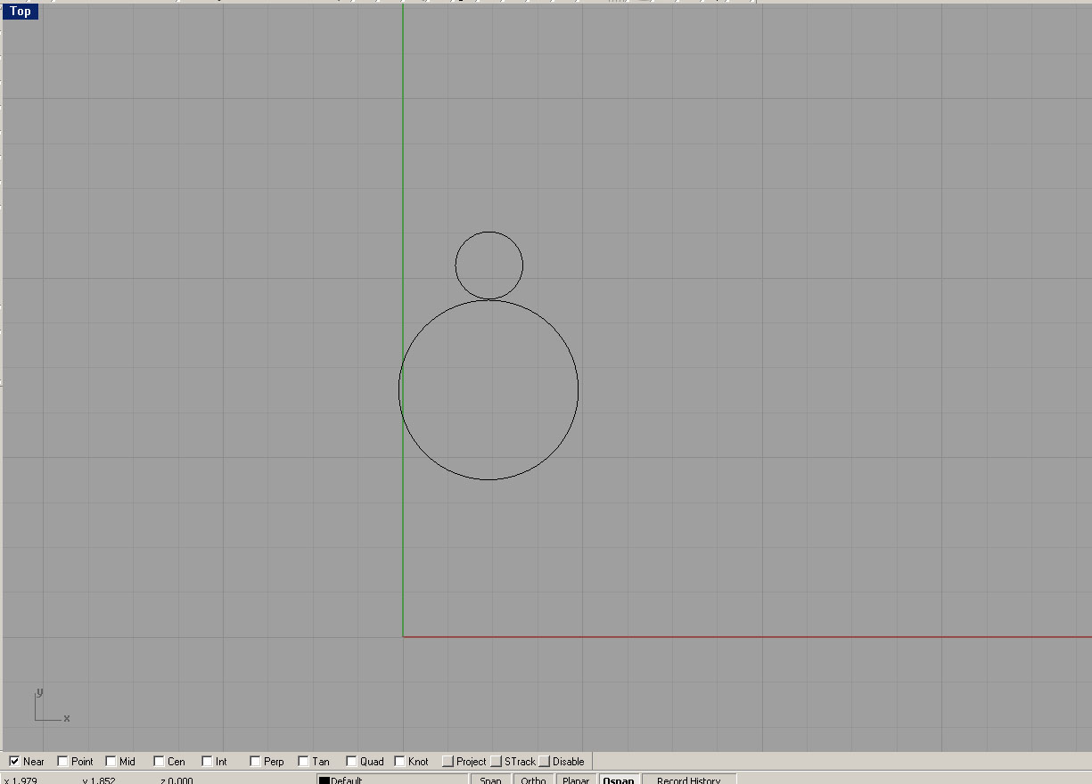
Move the smaller circle on top of the larger circle.

- Next, make sure Near is checked in the options at the bottom of the screen.
Make sure Near is checked.

- From the menu bar, left-click on Curve < Arc < Start, End, Radius.

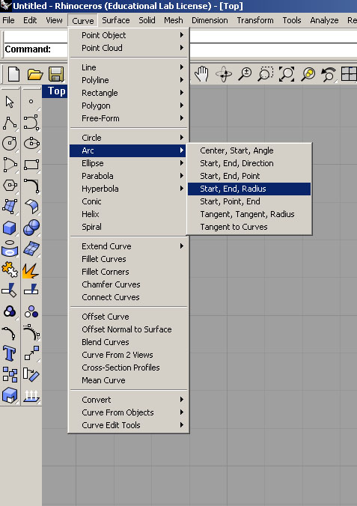

- Click on the upper half of the large circle. See below
.
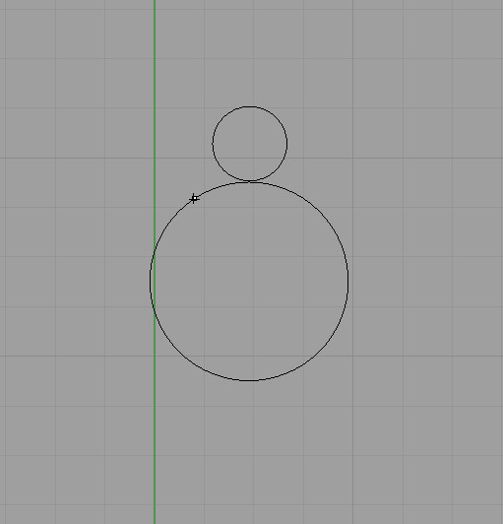
Left-click here.

- Then, click on the lower half of the smaller circle. See below.
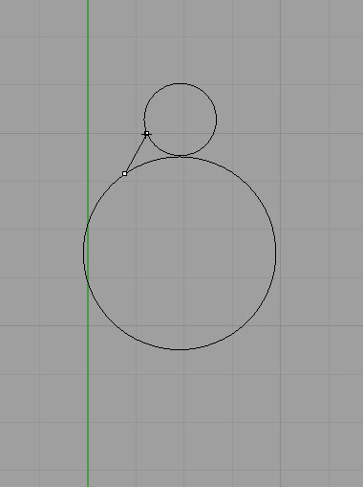
Left-click here.

- Move your mouse on the screen so you get an arc between the large and small circle. See below.
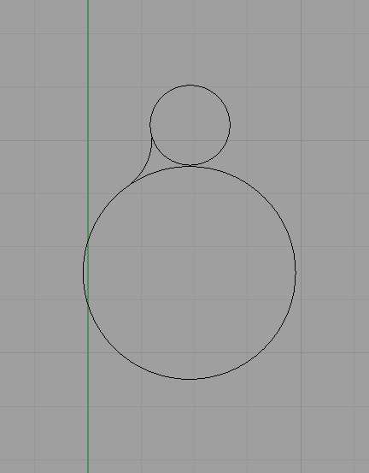

- Repeat Steps 8-11 so you have an arc on the other side of the circles. Your screen should look like below.
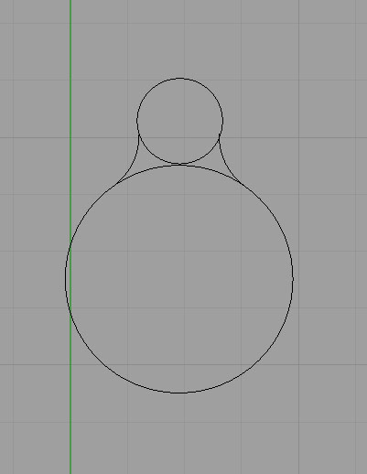

- Type Trim to activate the Trim command. See below.
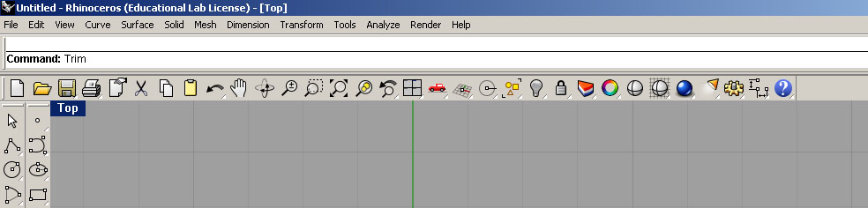
Type Trim here and press Enter.

- Click on both the arcs. They should turn yellow in color. Then, press Enter. See below.
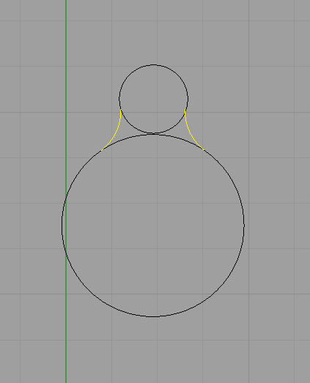
Click on the arcs, then press Enter.

- Then, click on the lower half of the small circle and the upper half of the large circle. The circles will be trimmed. Your screen should look like below.
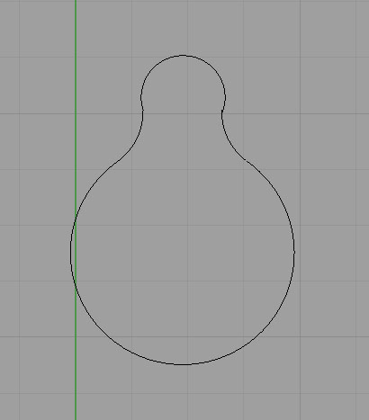

- Activate the circle too again. Then, click in the center of the small circle. Enter a value of .125 diameter and press Enter. Your screen should look like below.

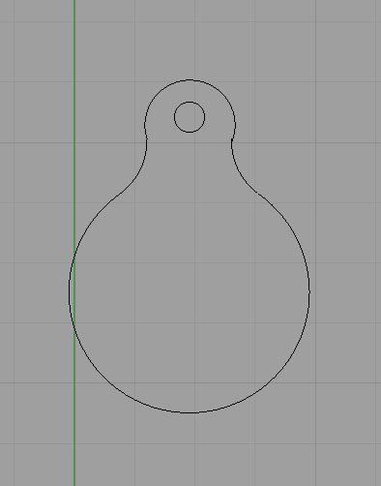
Circle .125 diameter.

- Double-click on the text Top. Your screen should look like below.

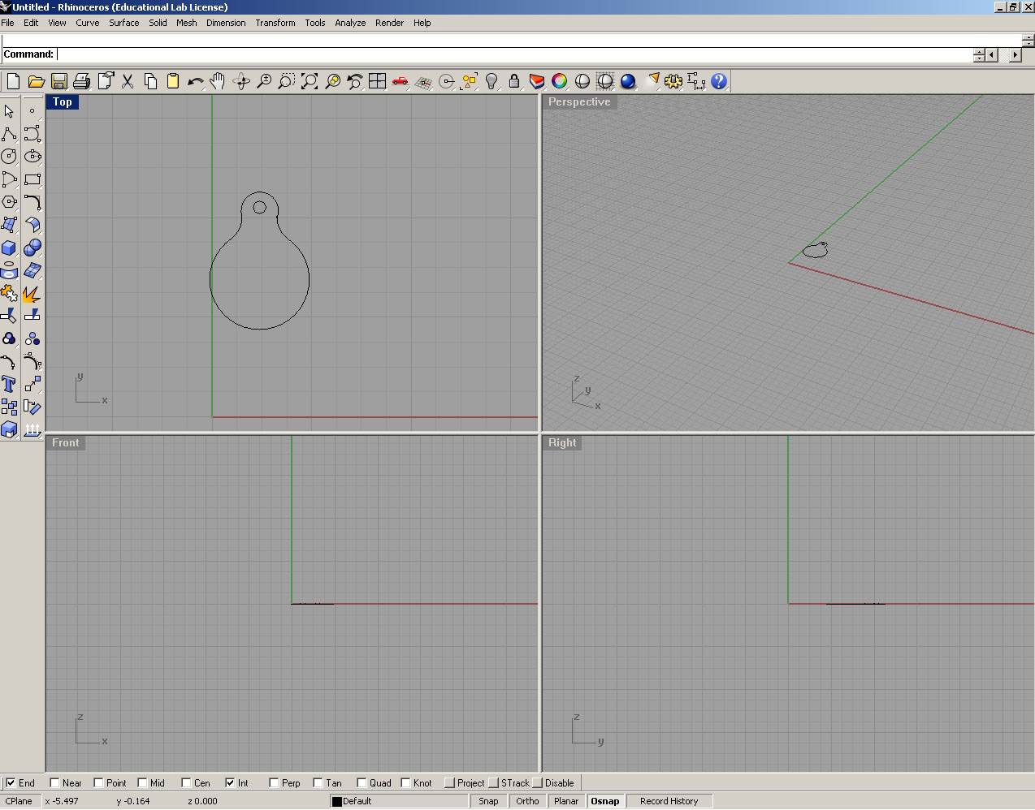
Double click here.

- From the menu bar, left-click on Edit < Select Objects < All Objects. Your circles should turn yellow in color.

- From the menu bar, left-click on Solid < Extrude Planar Curve < Straight.
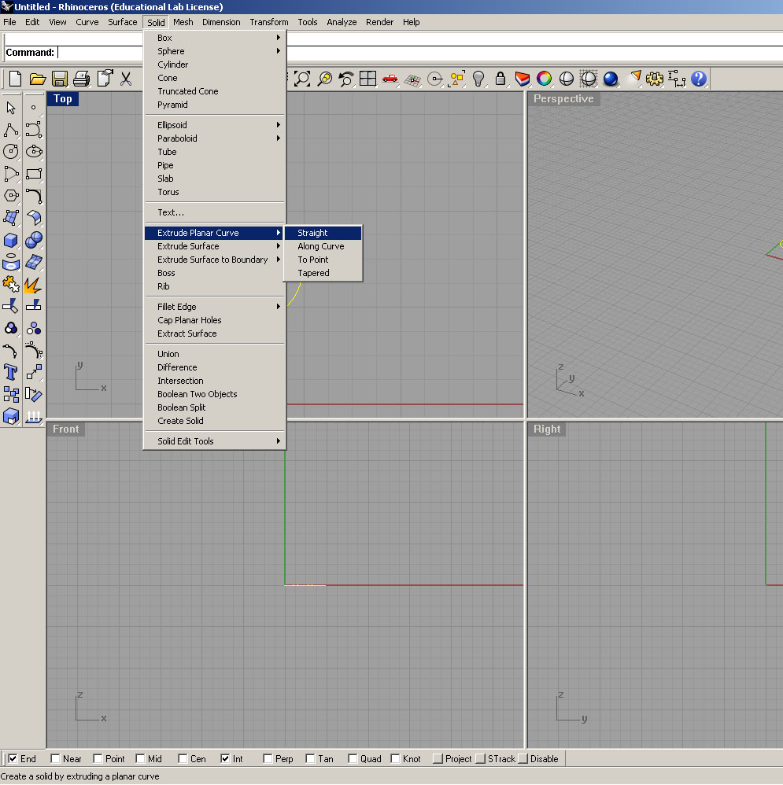

- Enter a value of .125 for the Extrusion distance. Press Enter.
Enter .125 here and press enter.

- Right-click on the text Perspective and choose Shaded. Your screen should look like below.
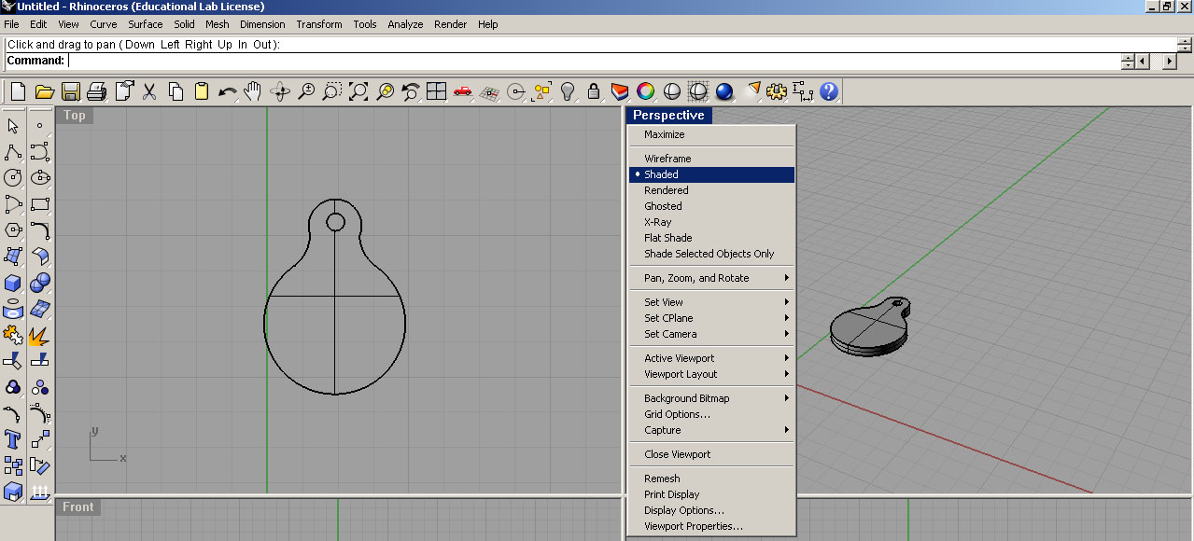

- From the menu bar, left-click on Solid < Text. Match the following settings and click OK.
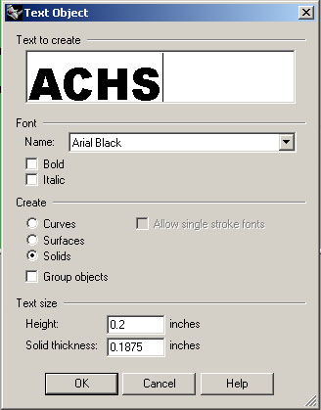

- **You may type different letters than ACHS. However, you may have to adjust the text Height value.
For instance, a smaller number results in smaller text. See below.
Smaller number here makes the text smaller.

- Move your mouse on the screen to center the text in the large circle. Left-click to commit. See below.
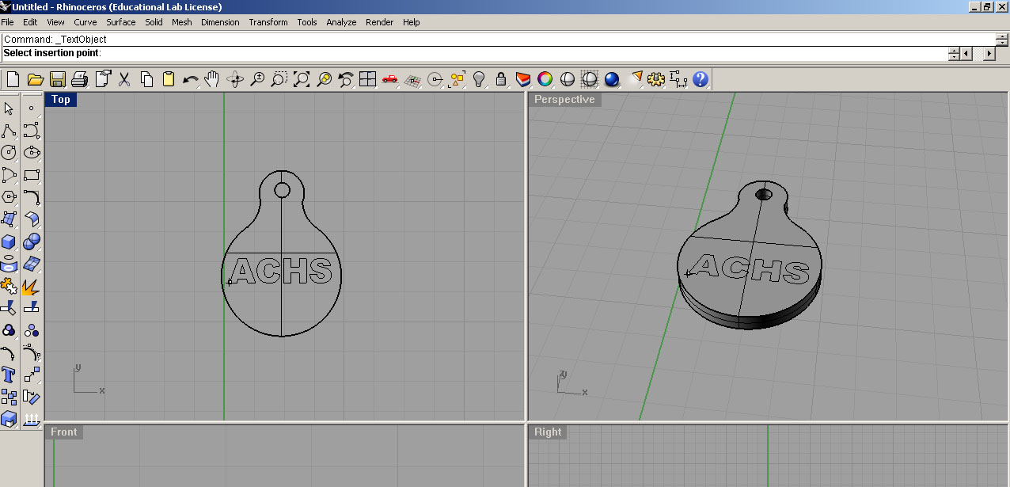
Center text, then left-click.
- Your screen should look like below.
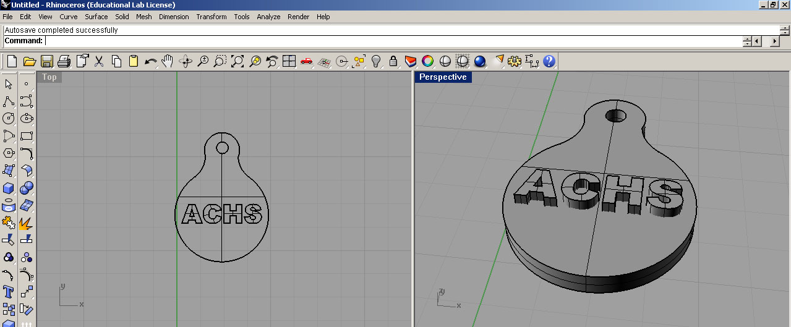

- Click File < Save As… to save your file. You must navigate and save to your Z:\ Drive!
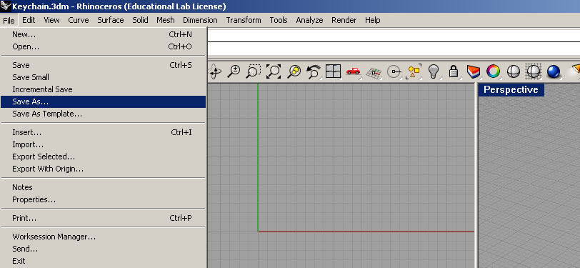

- Log onto your Gmail. Email (file attachment) your saved file to jon.salaban@chsd117.org

